2、
模块设计：
def insert():
# 获取输入框的值
snameValue = snameEntry.get()
ssidValue = sidEntry.get()
sphoneValue = sphoneEntry.get()
saddressValue = saddressEntry.get()
if snameValue == "" or ssidValue == "" or sphoneValue == "" or saddressValue == "":
messagebox.showwarning("警告", "学生的学号、姓名、电话、住址不能为空！")
else:
print("添加中......")
stu.setSaddress(saddressValue)
stu.setSname(snameValue)
stu.setSphone(sphoneValue)
stu.setSid(ssidValue)
bd.addStudent(stu)
# 添加之后重新加载表格数据
fresh()
clearEntry()
print("添加成功！")

def addStudent(s):
# list1 = []
# list1.append(s.getSid()())
# list1.append(s.getSname())
# list1.append(s.getSphone)
# list1.append(s.getSaddress)
connect = sqlite3.connect(dbstr)
cur = connect.cursor()
cur.execute("insert into student values('%s','%s','%s','%s')" % (s.getSid(), s.getSname(), s.getSphone(), s.getSaddress()))
connect.commit()
cur.close()
connect.close()
添加学生信息

def delete():
sidValue = sidEntry.get()
if sidValue != "":
print("删除中......")
sidValue = sidEntry.get()
stu.setSid(sidValue)
print(sidValue)
bd.delStudent(stu)
# 删除之后刷新数据
fresh()
# 清空输入框
clearEntry()
print("删除成功！")
elif sidValue == "":
# 用户没有选择任何学生进行删除
messagebox.showinfo("提示", "请输入学生学号以删除")

def delStudent(s):
connect = sqlite3.connect(dbstr)
cur = connect.cursor()
cur.execute("delete from student where sid='%s'" % s.getSid())
connect.commit()
cur.close()
connect.close()
删除学生信息

def update():
sidValue = sidEntry.get()
if sidValue != "":
print("修改中......")
sidValue = sidEntry.get()
snameValue = snameEntry.get()
sphoneValue = sphoneEntry.get()
saddressValue = saddressEntry.get()
stu.setSid(sidValue)
stu.setSname(snameValue)
stu.setSphone(sphoneValue)
stu.setSaddress(saddressValue)
bd.updStudent(stu)
fresh()
clearEntry()
print("修改成功！")
elif sidValue == "":
# 用户没有选择任何学生进行修改
messagebox.showwarning("警告", "请选择需要修改的学生")

def updStudent(s):
connect = sqlite3.connect(dbstr)
cur = connect.cursor()
sql = "update student set name='%s',phone=%s ,address=%s where sid='%s'" % (
s.getSname(), s.getSphone(), s.getSaddress(), s.getSid())
cur.execute(sql)
connect.commit()
connect.close()
修改学生信息

def select():
print("查询中......")
sidValue = sidEntry.get()
if sidValue != "":
sidValue = sidEntry.get()
snameValue = snameEntry.get()
sphoneValue = sphoneEntry.get()
saddressValue = saddressEntry.get()
if saddressValue != "":
saddressValue = saddressEntry.get()
stu.setSid(sidValue)
stu.setSname(snameValue)
stu.setSphone(sphoneValue)
stu.setSaddress(saddressValue)
for i in treeView.get_children():
treeView.delete(i)
for i in bd.selectStu(stu):
treeView.insert("", 0, values=(i[0], i[1], i[2], i[3]))
print("查询成功......")

def selectStu(s):
connect = sqlite3.connect(dbstr)
cursor = connect.cursor()
sql = "select * from student where 1=1"
if s.getSid() != "":
sql = sql + " and sid='%s'" % (s.getSid())
if s.getSname() != "":
sql = sql + " and name like '%%%s%%'" % (s.getSname())
if s.getSphone() != "":
sql = sql + " and phone='%s'" % (s.getSphone())
if s.getSaddress() != "":
sql = sql + " and address='%s'" % (s.getSaddress())
cursor.execute(sql)
data = cursor.fetchall()
connect.close()
return data
查询学生信息

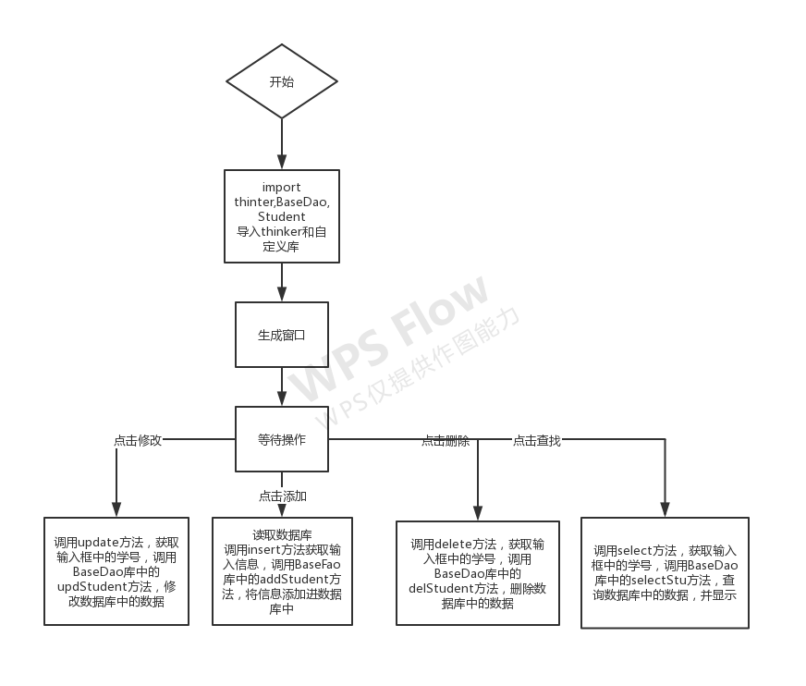
- 使用到的第三方库的介绍：
使用pip install thinter安装该图形库
使用pip install sqlite3

thinker库的使用及用到的函数的说明
# 实例化一个新窗口
tk = Tk()

# 设置窗口大小
tk.geometry("600x380")

# 设置窗口的标题
tk.title("学生管理系统\n")

# 在窗口中添加标签
label = Label(tk, text="欢迎使用学生管理系统！", bg="#0078D7", fg="black", font=("宋体", 18))

# 标签出现在窗口的位置
label.pack(side=TOP, fill="x")

# 在窗口中添加数据展示
# 设置show属性为 headings 即可隐藏首列
treeView = ttk.Treeview(tk, show="headings", column=("sid", "sname", "sphone", "saddress"))

# 数据列表设置属性
treeView.column("sid", width=150, anchor="center")
treeView.column("sname", width=150, anchor="center")
treeView.column("sphone", width=150, anchor="center")
treeView.column("saddress", width=150, anchor="center")

# 设置表头
treeView.heading("sid", text="学号")
treeView.heading("sname", text="姓名")
treeView.heading("sphone", text="电话")
treeView.heading("saddress", text="住址")

# 初始化加载表格的数据
fresh()

# 实例化底部大容器
bottomFrame = Frame(tk)

# 实例化底部大容器中的左右两个容器
leftFrame = Frame(bottomFrame)
rightFrame = Frame(bottomFrame)

# 左边容器
sidLadel = Label(leftFrame, text="学号：")
sidEntry = Entry(leftFrame)

snameLadel = Label(leftFrame, text="姓名：")
snameEntry = Entry(leftFrame)

saddressLadel = Label(leftFrame, text="电话：")
saddressEntry = Entry(leftFrame)

sphoneLadel = Label(leftFrame, text="住址：")
sphoneEntry = Entry(leftFrame)

sidLadel.grid(row=0, column=0)
sidEntry.grid(row=0, column=1)

snameLadel.grid(row=0, column=2)
snameEntry.grid(row=0, column=3)

saddressLadel.grid(row=1, column=0)
saddressEntry.grid(row=1, column=1)

sphoneLadel.grid(row=1, column=2)
sphoneEntry.grid(row=1, column=3)

# 右边容器
insertBtn = Button(rightFrame, text="添加", command=insert)
deleteBtn = Button(rightFrame, text="删除", command=delete)
updateBtn = Button(rightFrame, text="修改", command=update)
selectBtn = Button(rightFrame, text="查询", command=select)
insertBtn.grid(row=0, column=0)
deleteBtn.grid(row=0, column=1)
updateBtn.grid(row=1, column=0)
selectBtn.grid(row=1, column=1)

# 底部的【一键清空】按钮
clearButton = Button(text="一键清空", command=clearEntry)

# 给TreeView添加点击事件
treeView.bind("<<TreeviewSelect>>", treeViewSelect)

# 显示表的信息
treeView.pack()

# 显示左右容器
leftFrame.pack(side=LEFT)
rightFrame.pack(side=RIGHT)

# 显示底部大容器
bottomFrame.pack()

# 显示底部的【一键清空】按钮
clearButton.pack()

# 获取电脑屏幕的宽度和高度
winWidth = tk.winfo_screenwidth()
winHeight = tk.winfo_screenheight()

# 窗口的宽度
tkWidth = 600
tkHeight = 380

# 居中的px
x = (winWidth - tkWidth) / 2
y = (winHeight - tkHeight) / 2

tk.geometry("%dx%d+%d+%d" % (tkWidth, tkHeight, x, y))
# 进入消息循环
tk.mainloop()
Sqlite3库的使用及用到的函数的说明
#连接到数据库(dbstr)
connect = sqlite3.connect(dbstr)
#通过连接获取游标
cur = connect.cursor()
#使用游标执行SQL语句(词出为查询所有student表中的信息)
cur.execute("select * from student")
#获取结果集中的所有行
data = cur.fetchall()
#关闭浮标
cur.close()
#关闭数据库连接
connect.close()

- 在使用中遇到的问题及如何解决：
在使用过程中查询删除时对于字符串查询命令执行错误
解决方法：在查询命令中所要查询的字符串加上单引号，将所获取的信息变成字符串

- 效果和结论
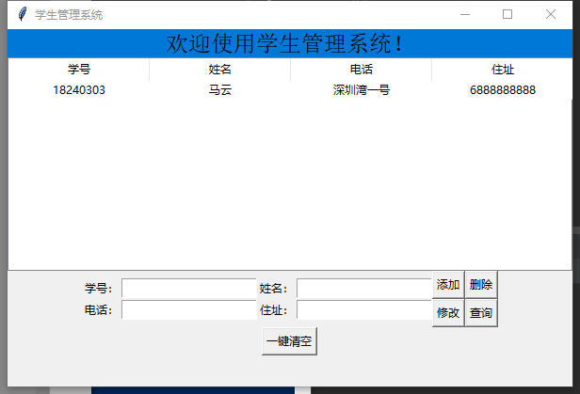
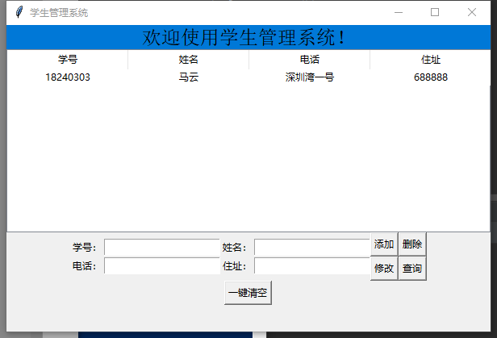
可以完善的地方：可加入成绩信息等，可美化一下界面

